**Operator Rule:**

**Admin@ALFA  ( Name, EmailID, Phone No, Access Group, ReportTo, Work Group, Work Basket, Routing Permissions)**

**Operator Is also a Rule in PEGA.**

**Operator is an instance of Data-Admin-Operator-ID**

**What is Operator Id Reference Class?**

**Data-Admin-Operator-ID**

**Open ur Operator ID & Update Name**

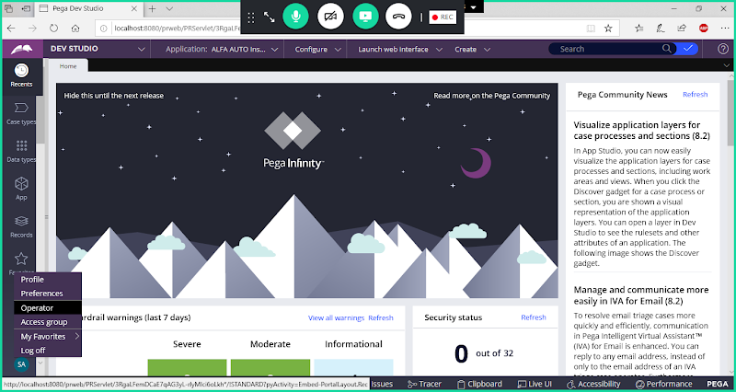

**When we click on Operator Option in Operator Menu-> It will open Operator Rule Form**

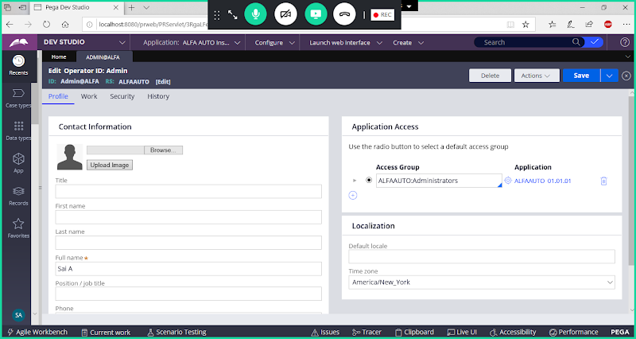

**Operator ID Information we can see in Clipboard under System Pages.**

**Open Clipboard:**

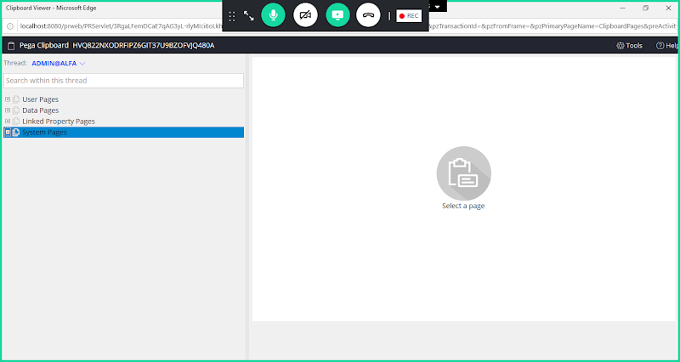

**Under System Pages-> OperatorID**

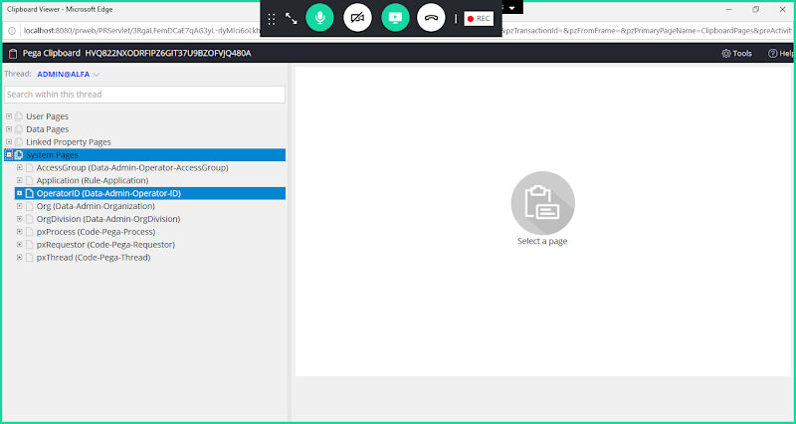

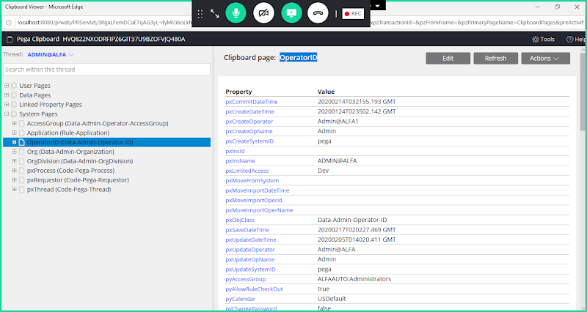

**Operator ID Related Properties:**

**pyUserIdentifier: Holds the Operator ID ( Admin@OrgName)**

**pyAccessGroup: Holds the Default Access Group (DivisionName:Administrators)**

**pyReportTo: Current operators Manager Operator ID**

**======**

**Add Reports to ID for Operator:**

**Open Existing Operator ID  Rule Form & use saveas option**

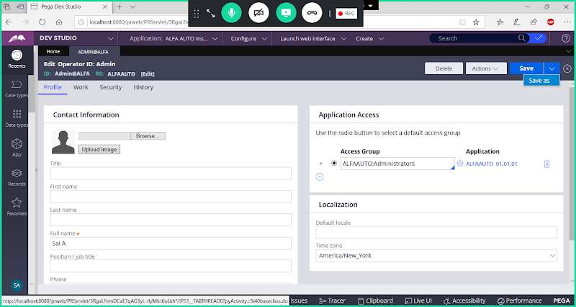

**Change Operator ID Name**

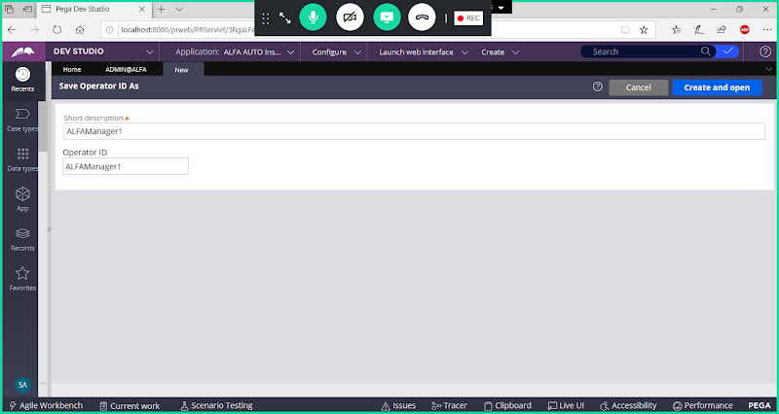

**Open**

**Change FullName & Access Group**

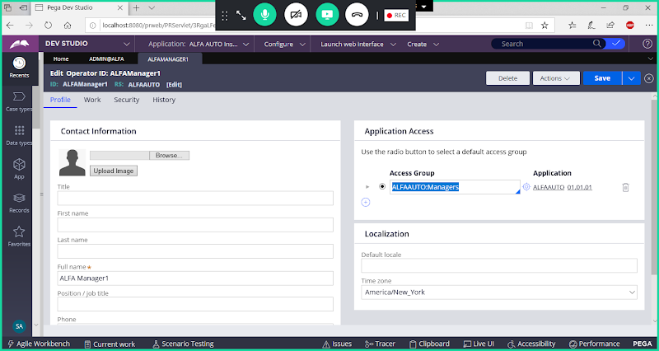

**Save Operator ID**

**Or we can Create Manager Operator ID from Organization Rule Type:**

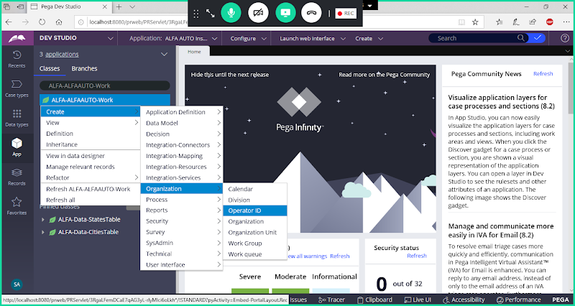

**Add Operator ID Name**

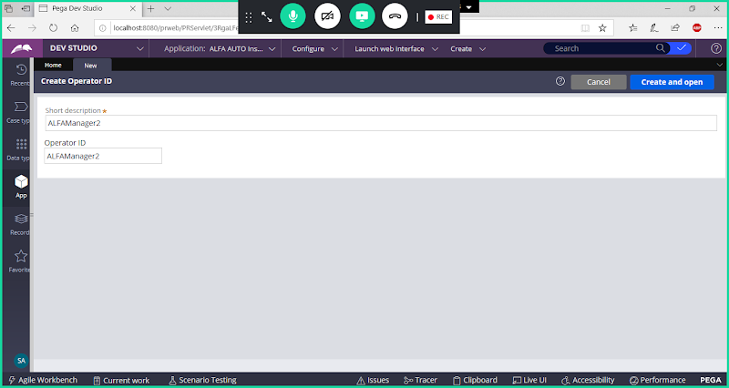

**Open**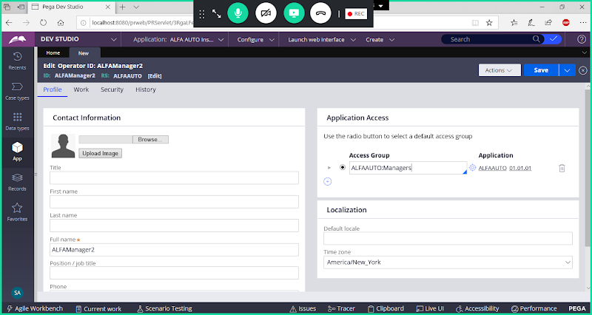

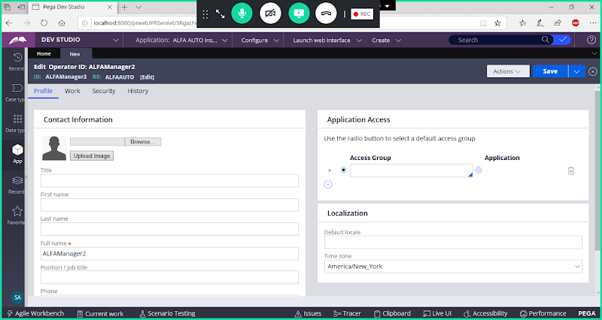

**Add Access Group Name**

**Now Go to Work Tab & Update Routing**

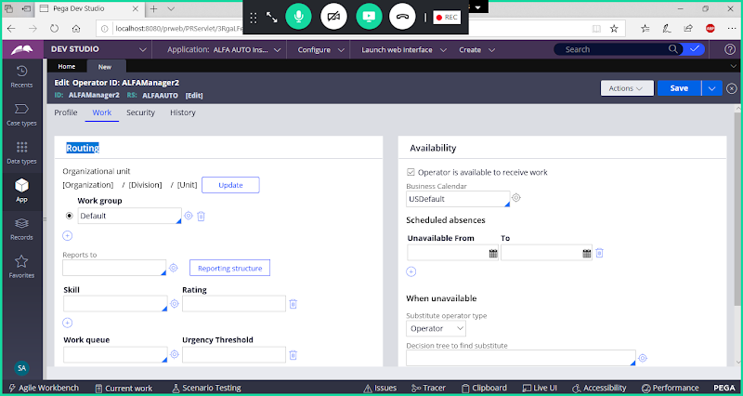

**Click on Update Button**

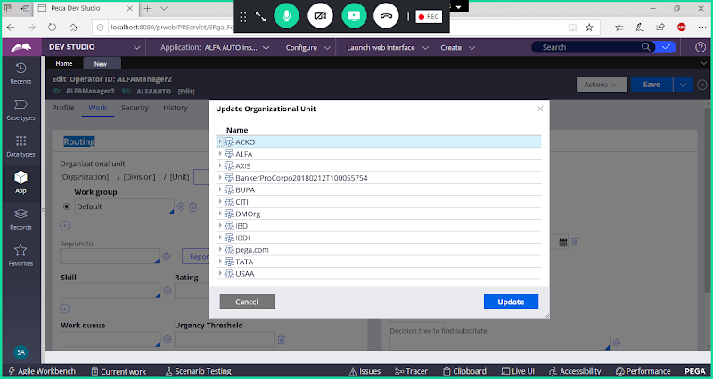

**Expand Org Name -> Expand Div -> Select Unit & Click on Update**

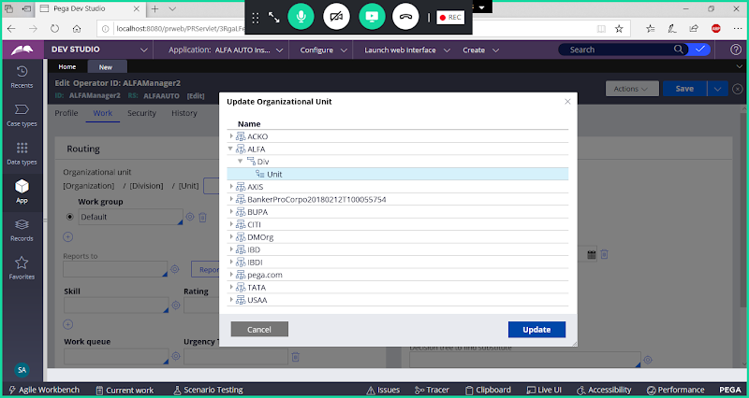

**Click on Update**

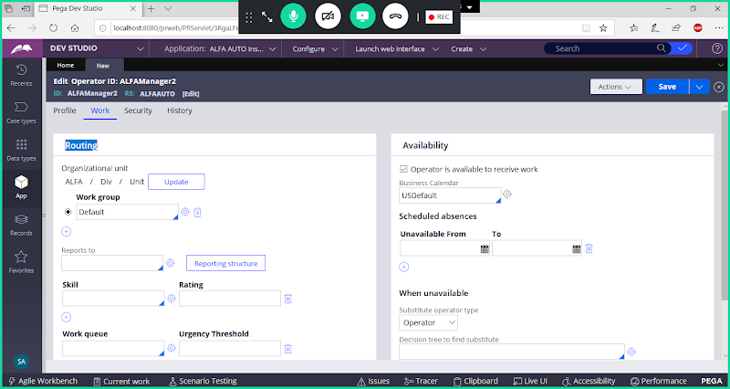

**Now Save Manager Operator ID**

**====**

**Add ReportTO ID for User ID**

**Now go to Operator ID**

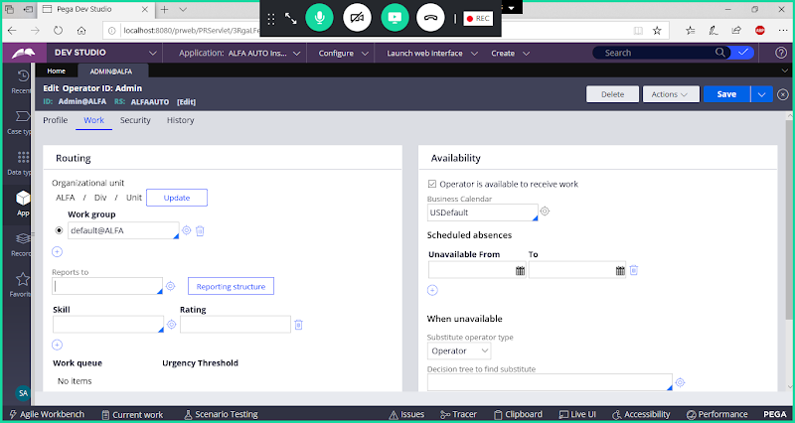

**In Work Tab:  Add ReportsTo**

**Under Reports add Manager Operator ID ( ALFAManager1)**

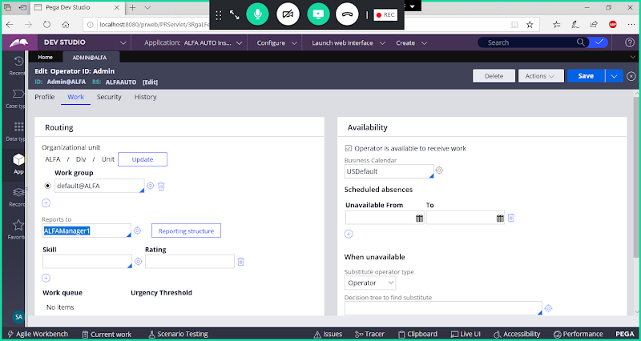

**Save Operator ID**

**===========**

**Routing: To Assigning/ Transferring work to someone**

**Work List/ To Operator : to Single Person**

**Work Basket/Work Queue: To Team  ( Any One Person from Team will be Working on that Ticket)**

**Work/My Case: Entire Transaction( Contains Multiple Work Items)**

**Work Item: 1 Assignment ( Portion of Work)**

**Routing can be done using Assignment Shape( Process Flow) or Entire Flow ( Screen Flow) we can Apply Routing.**

**Working with WorkList:**

**Req: Add a New Assignment for Manager Approval after Auto Vehicle Assignment & Route this assignment to Manager of Current Operator.**

**Open Operator ID Rule form and assign Manager ID form Work Tab -> Under Reports**

**Open Operator ID rule form & Go to Work Tab & Check ReportTo Id is Added or Not. If not added Create Manager ID & Add.**

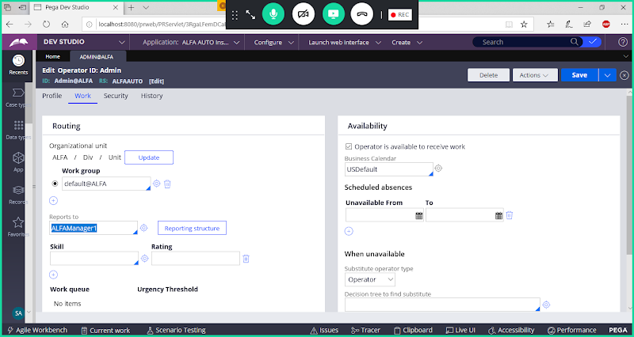

**Save**

**Create a Data Class: Approval**

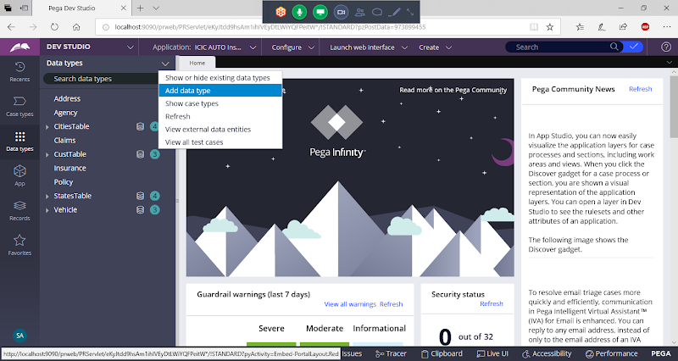

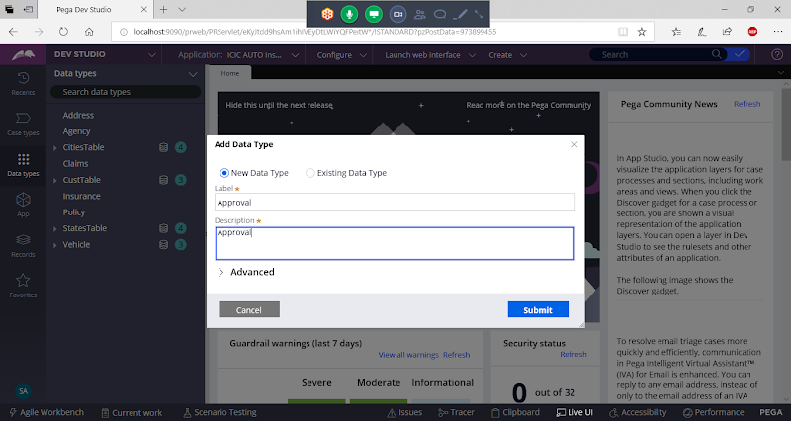

**Submit**

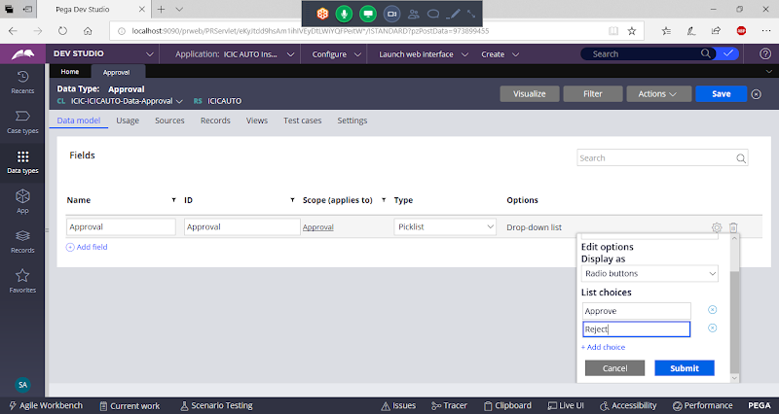

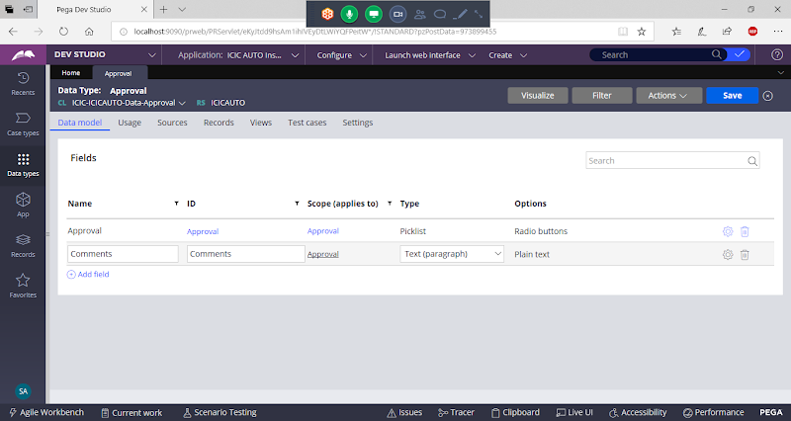

**=====**

**Add Section in Approval Data Class:**

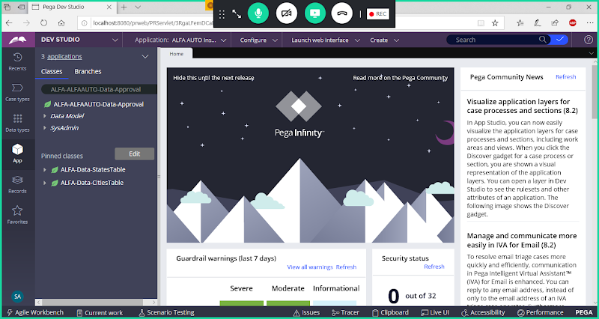

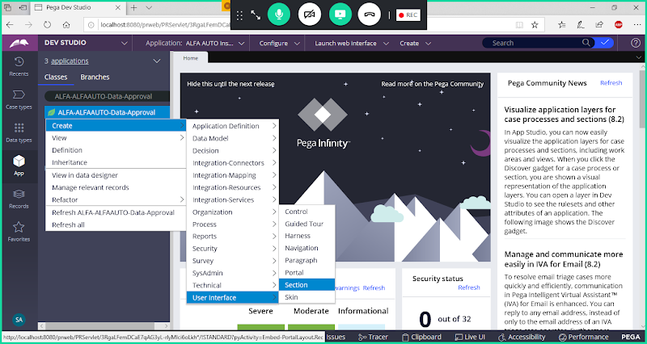

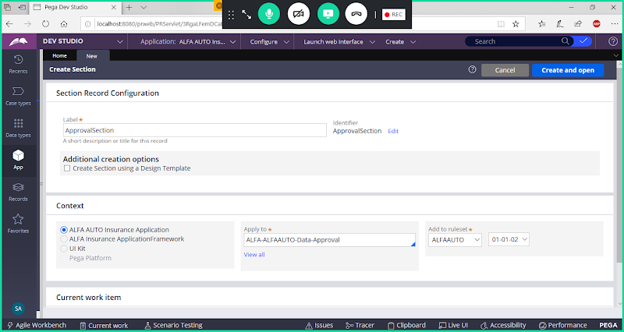

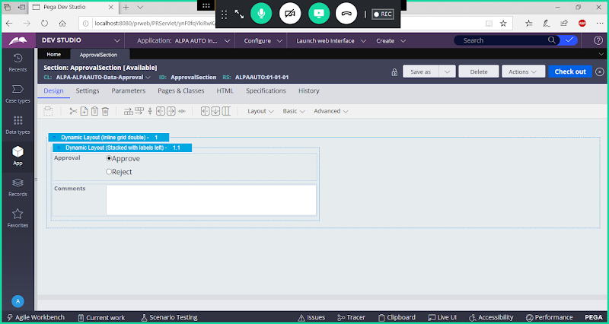

**Save section**

**==========================**

**Now go to work Layer:**

**Create a Page Property  Referring to  Approval Data Class in Work Class Group:**

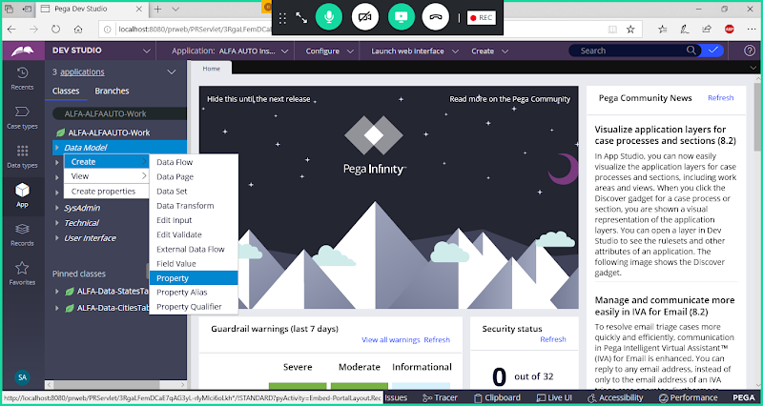

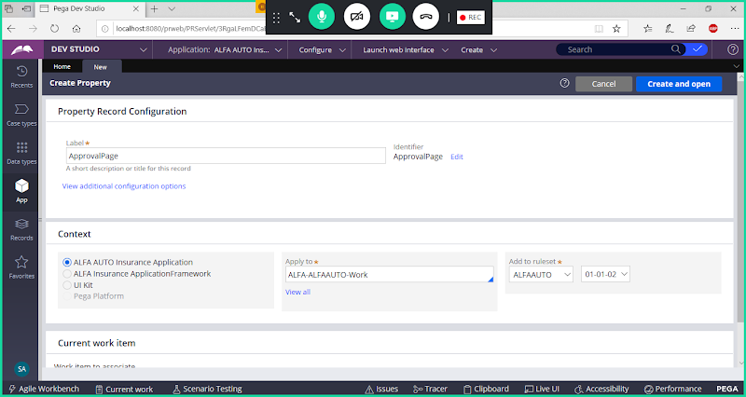

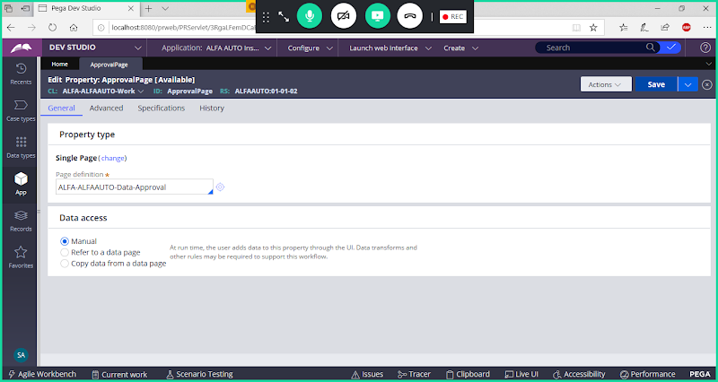

**Save Property**

**Add Flowaction in Work Class Group:**

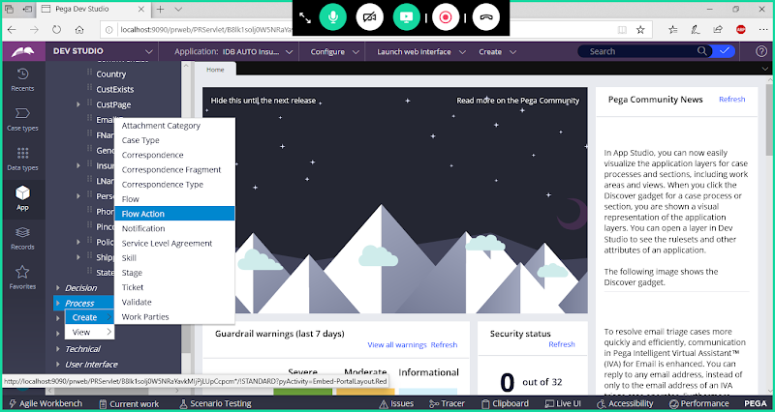

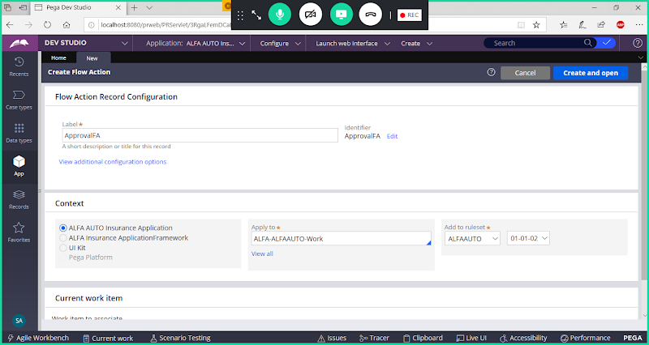

**Open**

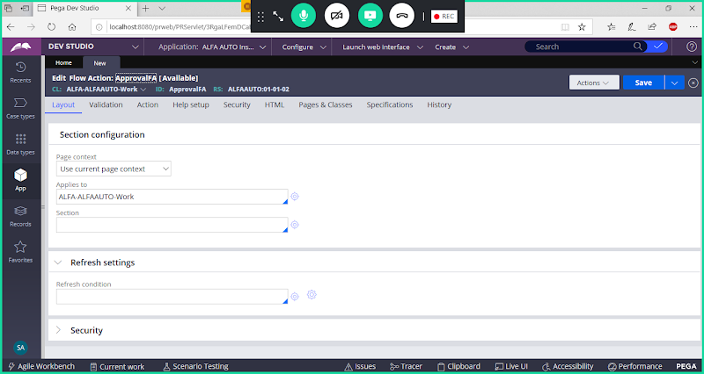

**By Default we cannot Access Approval Section name in the dropdown**

**Under Page context -> Select Use Clipboard Page & Add Page Property Name**

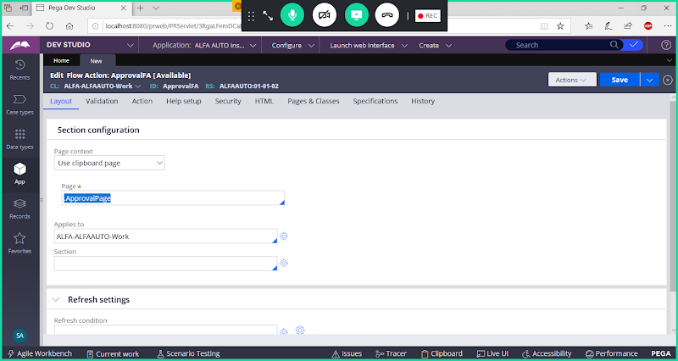

**In Applies to Give  Data Class Name:**

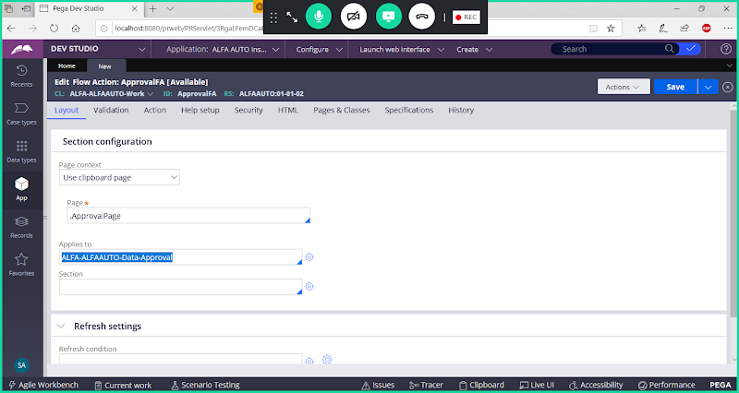

**Now you can add section name**

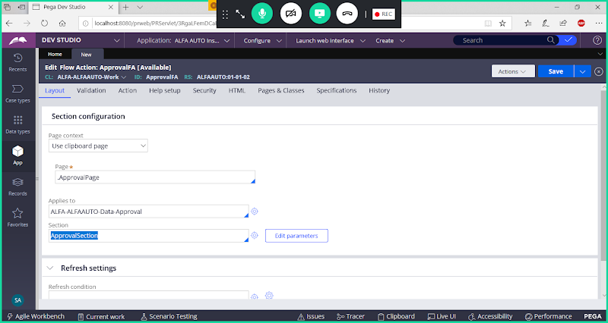

**Save Flowaction**

**Open Insurance Flow:**

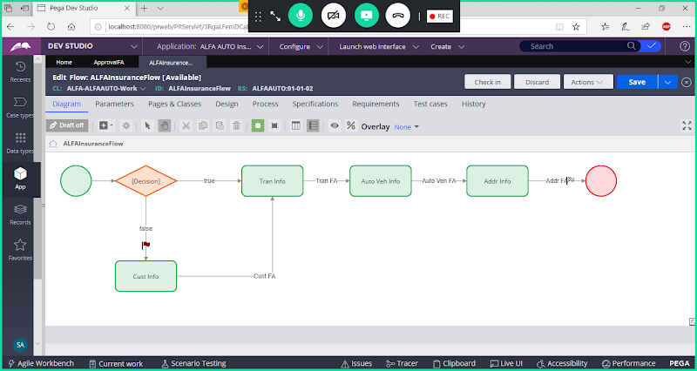

**Add Assignment after Auto Details Assignment & Call Approval Flowaction**

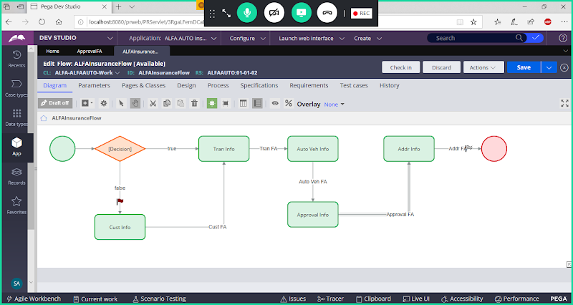

**Add Routing:**

**Route Approval Assignment to manager of Current Operator:**

**Open Approval Assignment Properties:**

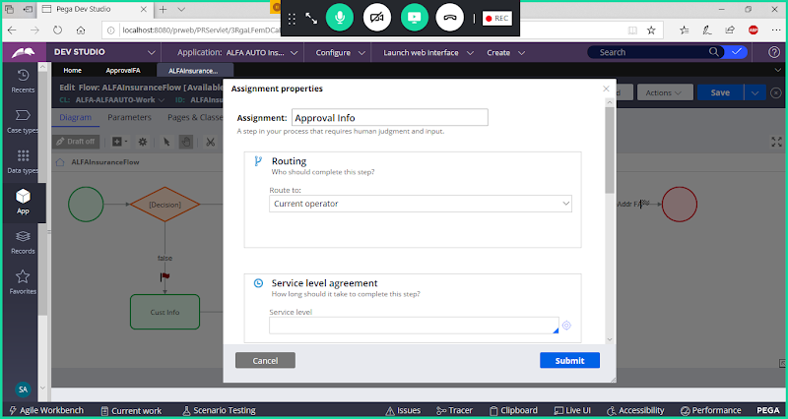

**Try to add Manager ID using Custom Option:**

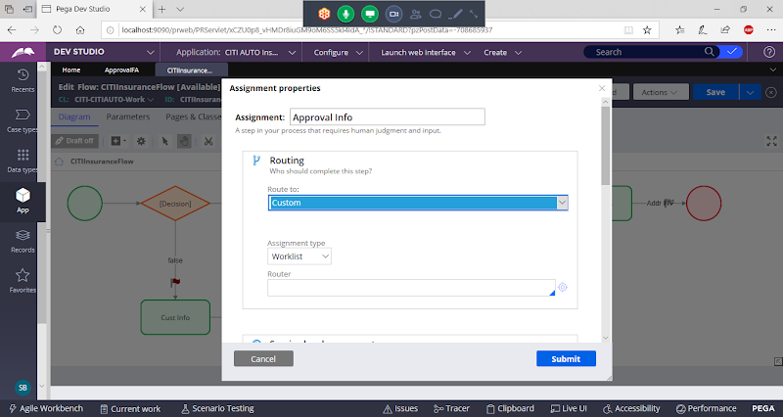

**Under Router -> Select  ToWorkList**

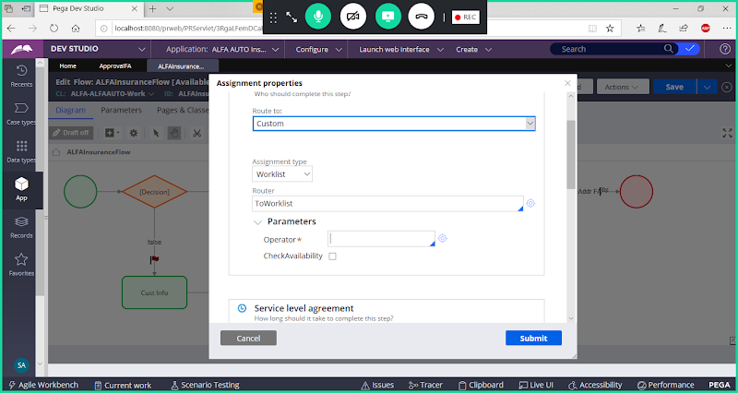

**Now Add Operator ID**

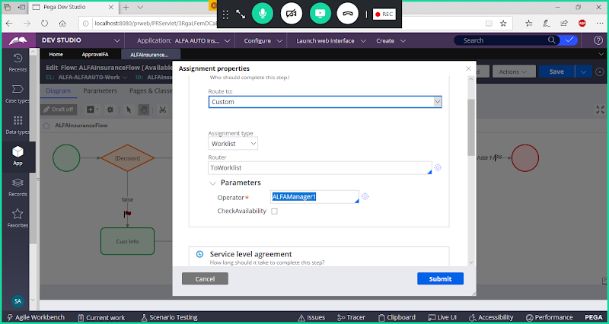

**Submit & Save Flow**

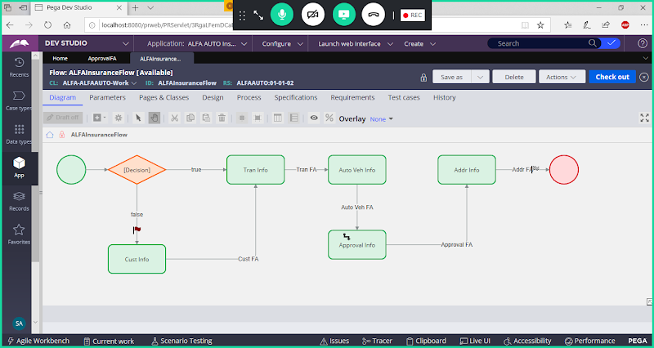

**Run Flow & Submit till Vehicle Form**

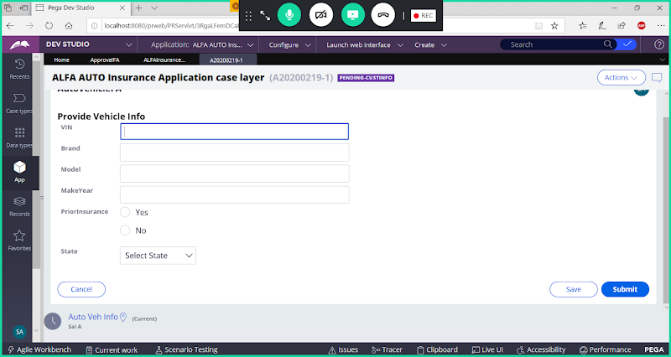

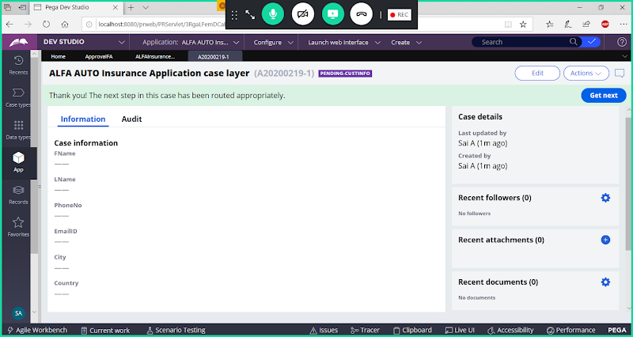

**Login with Manager Portal ID**

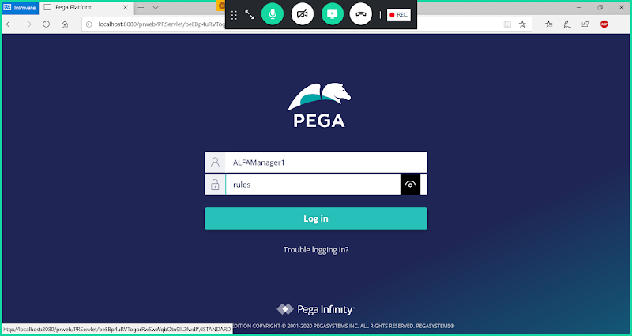

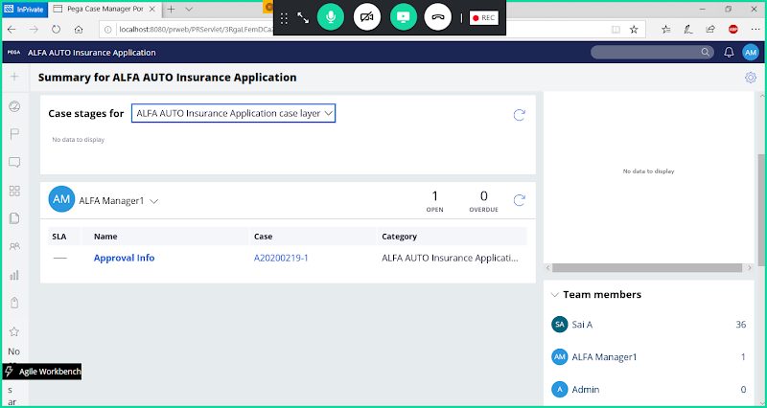

**Click on Work Item**

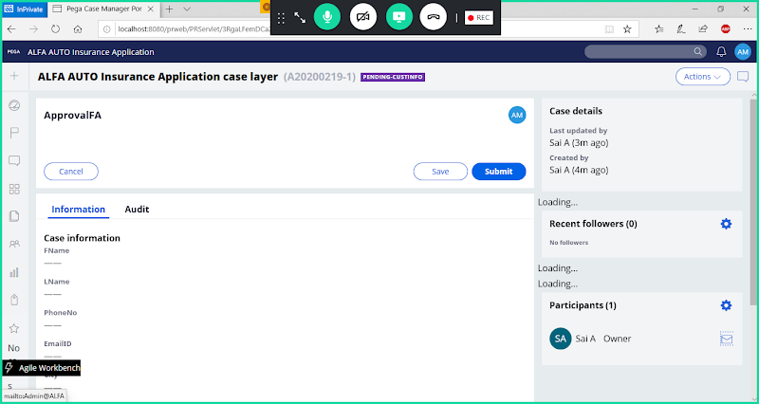

**Scroll down**

**We  get Flow action loaded but properties will not be displayed.**

**=====**

**Here your section properties are not loaded, because  ApprovalPage is not available in Clipboard. So the page is not available by the time page is loading**

**How to Make the Page Available:**

**Open Approval_Flowaction -> Go to Action Tab:**

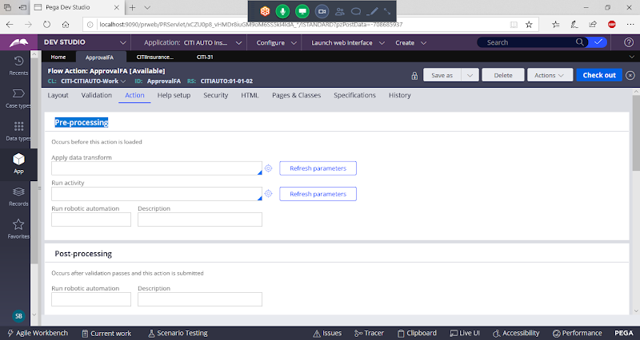

**Add Pre processing Activity/ Data Transform to set Approval Page in the Clipboard.**

**By the Time we access the Approval section the page on which it is loading( Approval Page) should be available on Clipboard else section will not be loaded in to Flow action. Make sure this page is created on Load of Flowaction.**

**Create Data Transform:**

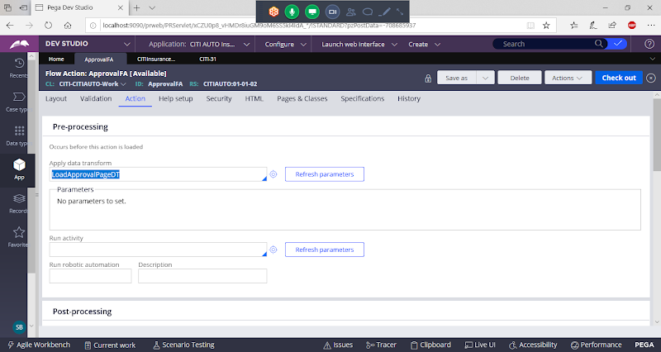

**open Data Transform**

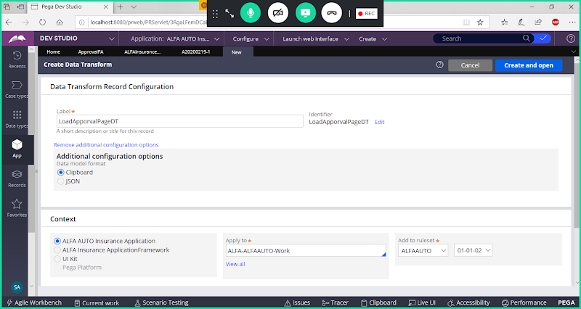

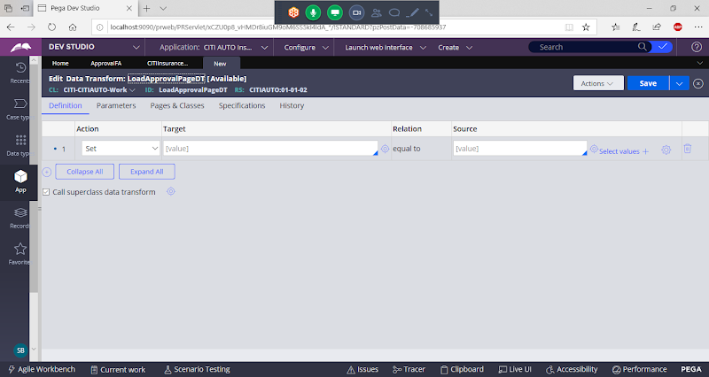

**Add Any One Property from Approval Page & Define Source as Null ( "")**

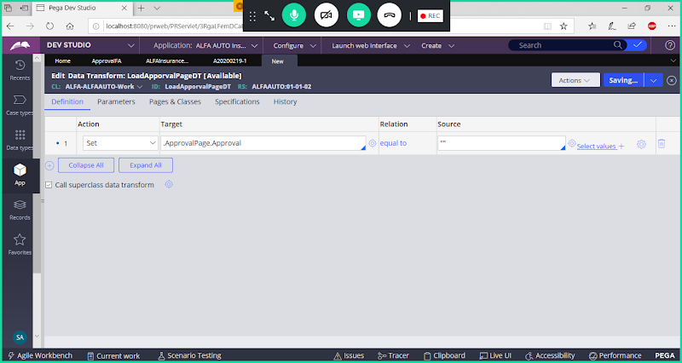

**Save Data Transform**

**Now Open Flowaction & Save**

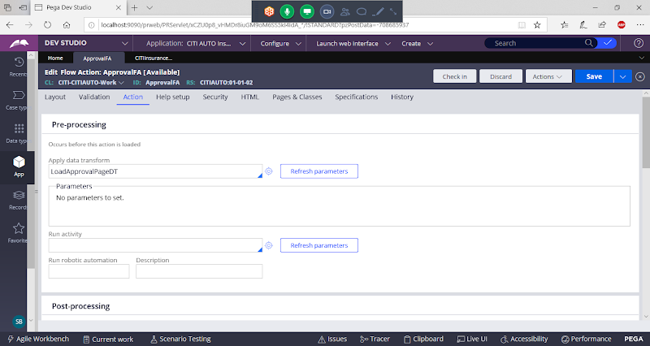

**Save Flowaction**

**Run the Flow again or Open Previous Work Item in Manager Portal ( In Manager Portal is already open means refresh portal)**

**Now Check in Manager ID**

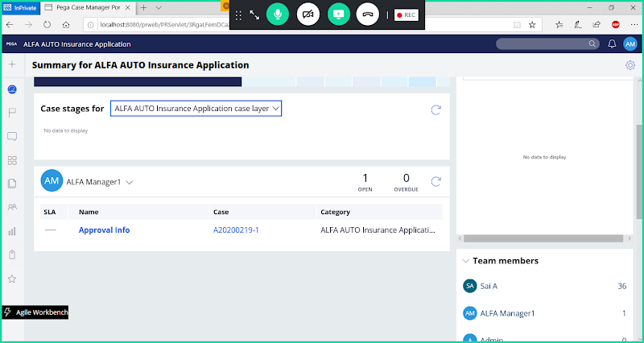

**Click on Work Item**

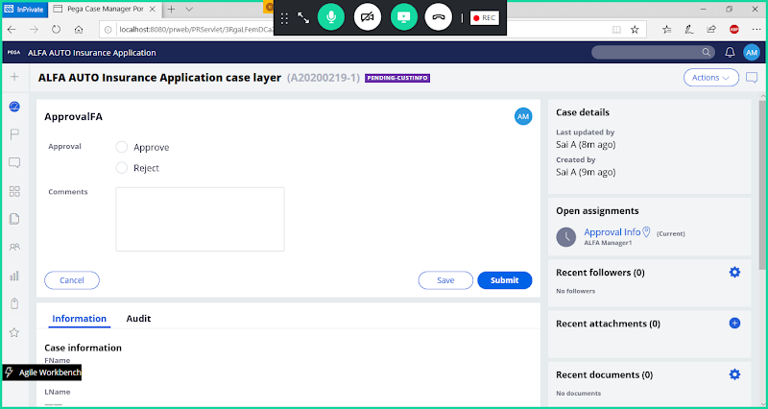

**Submit**

**Routing to Work list executes a Predefined activity: ToWorkList**

**When we route to worklist  data gets inserted to table: pc_assign_workList**

**=======================**